Acknowledgement of Agreement in Principle and Facilitation of Planning Motion
Dear Julian,
Further to the agreement in principle received from David Wilson Homes regarding the potential gifting of the existing marketing suite at Newbury Racecourse to Greenham Parish Council (GPC), subject to successful planning permission, this letter sets out a proposed pathway to formalise next steps in accordance with relevant UK law and governance procedure.
GPC and the RRA acknowledges the constructive discussions to date and welcomes the offer in principle made by David Wilson Homes. To progress this opportunity, and pursuant to the Local Government Act 1972 and the Town and Country Planning Act 1990, it is proposed that GPC members—who are also members of the Racecourse Residents Association (RRA)—be supported in bringing forward a motion to a full Council meeting to:
- Authorise GPC to prepare and submit a pre application enquiry followed by a planning application to West Berkshire Council for change of use of the existing marketing suite to a community facility. This will involve a full planning application as the building is due to be demolished at the end of the DWH build at the racecourse.
- Endorse the transfer of said building and associated land to GPC, conditional upon successful planning approval and without financial consideration, under the terms offered by David Wilson Homes;
- Commit to engaging residents, via the RRA and directly, in an inclusive consultation process on the proposed uses of the facility, to satisfy community needs and secure long-term benefit.
GPC affirms its responsibility under section 122 of the Local Government Act 1972 to acquire assets for public use where such acquisition contributes to the social wellbeing of the parish, subject to planning law and due diligence.
Should the motion be adopted, Council officers will be authorised to initiate discussions with West Berkshire Council’s planning department, thereby fulfilling procedural requirements and enabling a lawful and transparent planning application process.
This letter is appended to the motion as a record of support and procedural clarity.
Yours sincerely,
Adrian Abbs
Member of Greenham Parish Council

Draft Motion for GPC Council Meeting Agenda
Title: Motion to Submit Pre-application enquiry & a Planning Application for Retention and Transfer of David Wilson Homes Marketing Suite to GPC
Proposer: Cllr Adrian Abbs
Seconder: Cllr Steve Allan
Motion Text:
That Greenham Parish Council resolves to:
- Prepare and submit a planning application to West Berkshire Council seeking permission for change of use of the David Wilson Homes marketing suite, located within the Racecourse development, from temp use to a permanent community facility;
- Request formal confirmation from David Wilson Homes of their offer to transfer ownership of the building and associated land to Greenham Parish Council free of charge, conditional on successful planning permission;
- Engage in community consultation, in collaboration with the Racecourse Residents Association (RRA) and directly, regarding the proposed future use of the facility, to ensure alignment with local needs and public benefit;
- Create a committee (similar to the diamond build committee) so that relevant members have budget and authority to complete the necessary planning application;
- Authorise the Clerk to carry out all necessary actions to fulfil the above, including legal liaison, planning submission, and communication with relevant stakeholders.
- Set aside an initial budget of £50K in order to engage the relevant planning specialists
- Set aside budget for conversion of marketing suite to community facility including, but not limited to, fit-out, services, maintenance.
This motion is made pursuant to the Local Government Act 1972 (section 122), empowering the acquisition of land for public purposes, and the Town and Country Planning Act 1990 (section 62), concerning the lawful initiation of planning applications by local councils.

Appendix A – Proposed area to be included shown as dotted lines
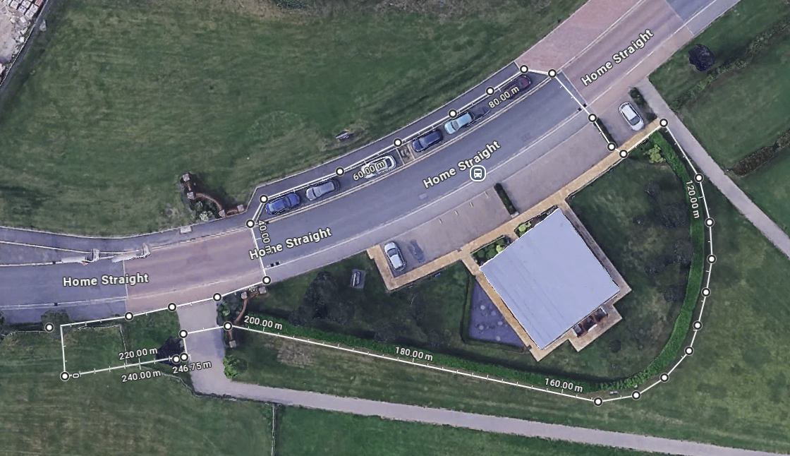
The dotted line runs along the existing hedge line of the marketing suite and includes parking currently used to access the Marketing suite. It also allows an area West of the Marketing suite for additional parking.

